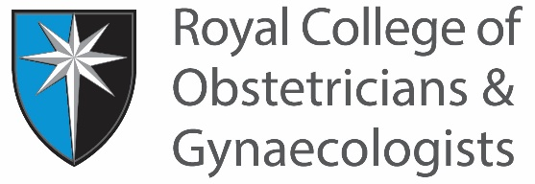
COMMITTEE/HONORARY POST
ROLE DESCRIPTION

Role Title | Member of the Global Health Trainees’ Committee
Reporting to | Chair and Vice-Chair of the Global Health Trainees’ Committee
Faculty Development Tier
(educational roles only)
Duration and Dates of Appointment | Three years or until CCT, 18 months minimum  Start date September 2022
Purpose and description of role
The RCOG Global Health Trainees’ Committee contributes to the development and implementation of the RCOG’s Global Health Strategy. The Committee serves as a platform for trainees with interest in women’s global health and works closely with the National Training Committee and other related RCOG Global Health committees. Specific activities include advocacy, supporting RCOG initiatives and assisting with the development of educational resources and guidance in women’s global health.
There is currently one vacant position available on the committee.
Main responsibilities
Current members are trainee doctors in Obstetrics and Gynaecology from various regions of the UK, at different stages of training with a broad range of clinical and research expertise in low and middle-income settings.
The main responsibilities of members of the committee are to:
1. Assist the RCOG to help develop and implement its Global Health Strategy
2. Facilitate knowledge exchange and sharing of expertise between trainees in the UK and international trainees
3. Be involved in engagement activities to raise awareness of global women’s health issues among UK trainees at both undergraduate and postgraduate stages to inform and help stimulate interest and engagement in global women’s health.
Key working relationships
- Chair and Vice-Chairs of the committee
- Other members of the committee
- Members of the RCOG Global Health Board
- Members of the RCOG Centre for Women’s Global Health
- Members of the RCOG Medical Training Initiative and Volunteering Committee
Time commitment
The Committee will meet four times per year and meetings are usually remote/virtual. Members will be expected to attend all committee meetings.
There will be significant commitment outside of the meetings to help with the development and implementation of projects that the Committee will deliver.
There will also be public engagement activities that all members are encouraged to undertake, for example invited speakers at conferences.
All committee members should have a minimum of 18 months of training until CCT.

Evaluation of the role and succession planning
This role reflects the present requirements of the post. As duties and responsibilities change and develop the role description will be reviewed and be subject to amendment in consultation with the post holder. The role description will be re-evaluated at the end of the term.

Person Specification

Qualifications / Training
Essential
  - Trainee doctor in Obstetrics and Gynaecology
  - Registered with a licence to practice with GMC, in good standing
Desirable
- DRCOG or MRCOG

Previous experience
Essential
- Evidence of commitment to promoting and improving global women’s health.
- Demonstrable experience of working in a low resource setting in a clinical setting or research capacity.
- Working knowledge and experience of evidence-based interventions that improve global women’s health outcomes.
Desirable
- Experience of developing proposals
- Authorship on peer reviewed publications related to global health.
Key skills / attributes
- Passion to improve women’s health in low resource setting.
- Good interpersonal skills.
- Confident communicator.
- Ability to work productively and co-operatively as a team member.
- Evidence of working to deadlines.

