Thematic Report
Educational Supervision

December 2023
Educational Supervision

Authors: Dr Christy Lamont, ST7 Trainee, NHS Education for Scotland; Dr Kelsie Sykes, ST7 Trainee, HEE East of England region; Dr Elisabeth Peregrine, Consultant, HEE South London region

Background
The purpose of Educational Supervision within Obstetrics and Gynaecology is to support the progression of trainees along the training pathway with respect to acquisition of knowledge, clinical skills and competencies. Where it is performed well, it enhances clinical and professional skills and attitudes through regular teaching, monitoring and feedback, and through this ensures good patient experience and safety.

The role of the Educational Supervisor within specialty training is now even more important with the introduction of the RCOG 2019 curriculum. This curriculum saw an increased responsibility of the Educational Supervisor with regards to global assessment of their trainees. This requires regular contact with trainees and a close knowledge of clinical competence in order to make this assessment of entrustability and to prepare for the Annual Review of Competency Progression (ARCP).

Studies into supervision have showed that it is deemed more effective when the supervisor is highly knowledgeable and motivated, which leads them to provide more credible feedback and input into training. A multiregression analysis by Gregory et al has been performed into the responses from the GMC training surveys from 2012 to 2015 and shows that key factors in determining Doctors’ satisfaction are strong clinical supervision, frequent and useful meetings, and a supportive working environment. These indicators have been investigated as part of the RCOG TEF from 2016 onwards.

The most recent TEF thematic report in 2021 focussed on Educational Supervision following implementation of the 2019 curriculum; questioning the preparedness of the supervisors for the new curriculum, the frequency of meetings following the implementation of the new curriculum and whether trainees felt that supervisors were able to provide a valid global assessment. The report revealed overall a high level of satisfaction from trainees with regards to their educational supervision, with 91% believing that their supervisor knew them well enough to provide an accurate assessment of their training progress. 85% of trainees had met with their Educational Supervisor more since implementation of the new curriculum, with the main barriers to this being lack of time due to clinical commitments of both the trainee and the supervisor. One point highlighted in the report was that having a supervisor who purely practiced either Obstetrics or Gynaecology was unhelpful to their training in both aspects of the speciality.

The 2023 TEF report into educational supervision will move away from the implementation of the new curriculum, accepting this as now embedded into training in the UK. We aim to; summarise trainee’s view on educational supervision in the UK, explore its impact on trainees and their perception of training and highlight areas of excellence and deficiency.

Questions
The questions from the TEF that were analysed to formulate this report are listed below;
Demographics
Deanery/HEE region
ST year
Are you currently training LTFT?

Educational Supervision
I was able to meet with my educational supervisor within 2 weeks of starting my new post
My induction meeting included an effective assessment of previous experience and competence and my learning needs
My last ARCP was fair

If you feel your last ARCP was unfair please state why

The process for my last ARCP was transparent

My educational supervisor is familiar with the RCOG curriculum

My educational supervisor can use the ePortfolio effectively

Advanced Training
Please select the first ATSM you are registered for.

I was able to have an induction/appraisal meeting with my ATSM supervisor for this ATSM

My induction meeting included an effective assessment of previous experience and competence and my learning needs

I was able to have regular meetings with my ATSM supervisor to review my progress and ongoing learning needs

Attrition
Since starting speciality training how often have you thought of leaving O+G?

If you have or would ever consider leaving speciality training what reasons would you give?

Non-clinical development
I was given sufficient independence and clinical responsibility appropriate to my level of training (i.e. given the opportunity to practice independently)
I had sufficient opportunity to develop management and leadership skills

I have had the opportunity to develop my teaching and training skills

Trainers were supportive in completing NOTSS assessments

Workplace based behaviours
As an O+G trainee in this unit, I feel valued in the workplace

This unit has a sense of community and belonging

In this post I have witnessed behaviour which I would consider commendable

Do you feel you are actively supported to achieve more in your career?

I feel that equality, diversity and fairness are embedded in my training and learning environment
My workplace based assessments are fair and unbiased

Clinical supervision
My clinical supervisors have provided me with feedback that is constructive and helpful

I have had appropriate supervision for my level of training in gynaecology clinic

I have had appropriate supervision for my level of training in gynaecology outside of normal hours
I have had appropriate supervision and support whilst on labour ward - outside of normal working hours
Trainers were supportive in completing the required obstetric workplace-based assessments
My clinical supervisors have provided me with feedback that is constructive and helpful

Analysis

“Adequate educational supervision” was considered when an initial meeting was completed within the first two weeks of a training post, which the trainee felt an effective assessment of previous experience and learning needs, and was carried out by a supervisor who was familiar with the RCOG curriculum and could use the ePortfolio effectively.

Using this criteria, overall 66.2% of respondents had adequate educational supervision. There was no statistical difference in perception of adequate educational supervision when categorised by LTFT status. There was an association between more experienced trainees being more likely to have adequate educational supervision: 60.0% of ST1-2 had adequate educational supervision vs 76.2% of ST6-7 respondents.

This trend was borne out in supervision for ATSMs, although direct comparison was not possible as the timing of the supervisor meeting with ATSM supervisor was not investigated: 82.8% had an initial meeting, 78.1% found the meeting useful and 71.5% had regular meetings. This was consistent across both primary and secondary ATSMs.

Geographical differences
The proportion of respondents with adequate educational supervision varied across the deaneries in the UK. The highest percentage of respondents occurred in North West London, followed closely by Scotland and Kent, Surrey and Sussex (KSS).

Deanery | Number of respondents with Adequate  Educational Supervision | Total respondents in Deanery | Ascending Percentage of Respondents with Adequate Educational Supervision
Wales | 32 | 60 | 53.3
East Midlands | 73 | 122 | 59.8
Thames Valley | 44 | 72 | 61.1
Yorkshire and Humber | 112 | 182 | 61.5
West Midlands | 86 | 136 | 63.2
North, Central and East London | 75 | 116 | 64.6
Wessex | 43 | 64 | 67.2
South London | 75 | 109 | 68.8
North West | 157 | 226 | 69.5
East of England | 97 | 139 | 69.8
Northern Ireland | 42 | 60 | 70
North East England | 62 | 87 | 71.3
South West | 85 | 118 | 72.0
Kent, Surrey and Sussex | 86 | 116 | 74.1
Scotland | 104 | 140 | 74.3
North West London | 79 | 105 | 75.2

ARCP Perception
Adequate educational supervision has a statistically significant effect on respondents’ perception of their Annual Review of Competency Progression (ARCP) as fair and transparent. Where the educational supervision is adequate, 88.3% of respondents felt the ARCP was fair and 84% felt ARCP was transparent vs 80.2% perceived fairness and 72.7% perceived transparency without adequate Educational Supervision.
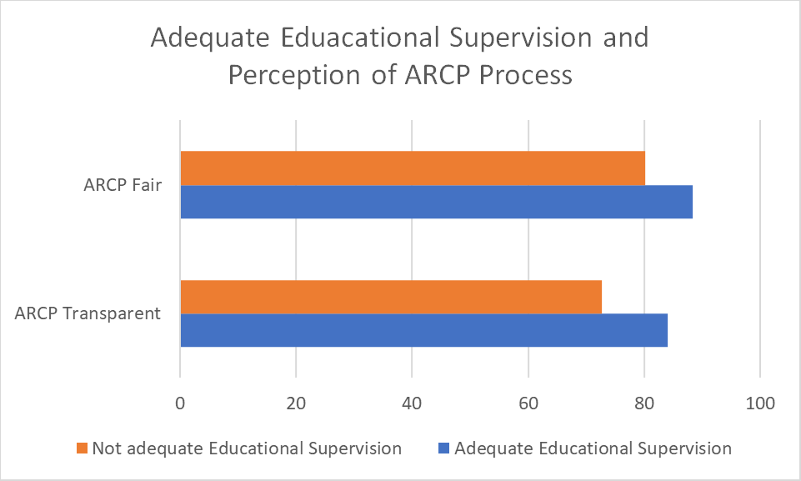
The biggest influence on this perception is whether the Educational Supervisor is familiar with the RCOG curriculum: where the Educational Supervisor is considered familiar with the curriculum, the perception of ARCP fairness is 86.8% compared to 73.6% where they are not familiar. Similarly, the transparency of the ARCP process where ES is adequate is 82.1% vs 61.6% where they are not.
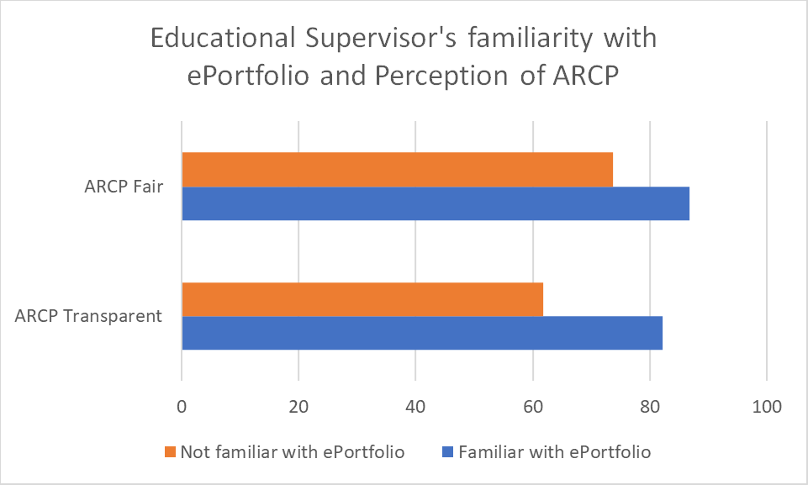

Attrition Rates
Attrition rates were measured by asking respondents how often they thought of leaving the specialty (never, occasional, monthly, weekly or daily). Where Educational Supervision was adequate, respondents thought of leaving the specialty less often. Poor Educational Supervision was featured in 6.7% of respondents’ reasons for considering leaving the speciality, which was one of the less common reasons for attrition.

Workplace Based Behaviour
Adequate Educational Supervision was significantly associated with a promotion of good workplace based behaviours. A sense of community and belonging, feeling valued in the workplace, witnessing commendable behaviour and embedding of equality and diversity were all more likely with adequate Educational Supervision compared to inadequate Educational Supervision.
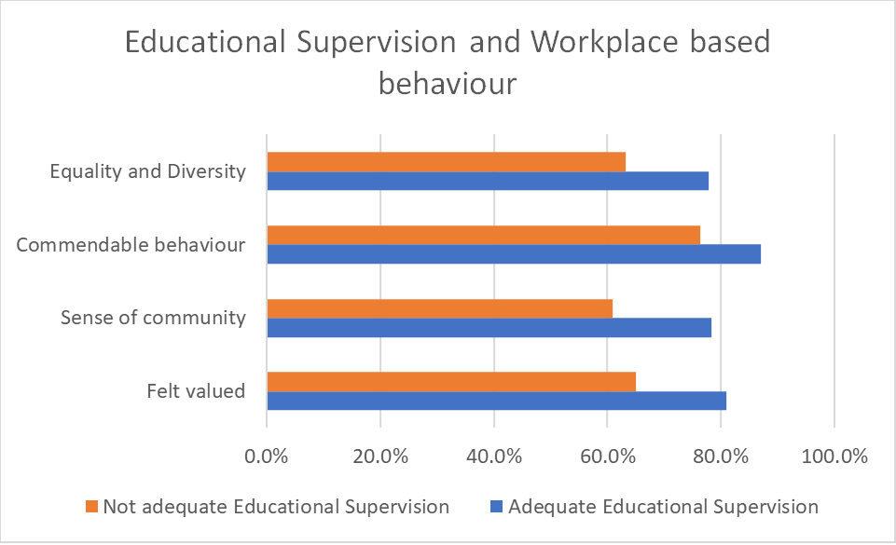

Non-clinical professional development
The respondents’ perceived ability to develop skills in leadership and teaching was significantly adversely affected where Educational Supervision was not adequate. Where adequate Educational Supervision was provided, 80.8% of respondents felt able to develop leadership skills as opposed to 74.7% without. Similarly, 85.7% of respondents developed teaching skills with adequate Educational Supervision compared to 72.2% without. When asked if they were “able to achieve more in their career” 86.1% of respondents with adequate Educational Supervision agreed compared to 66.2% without.
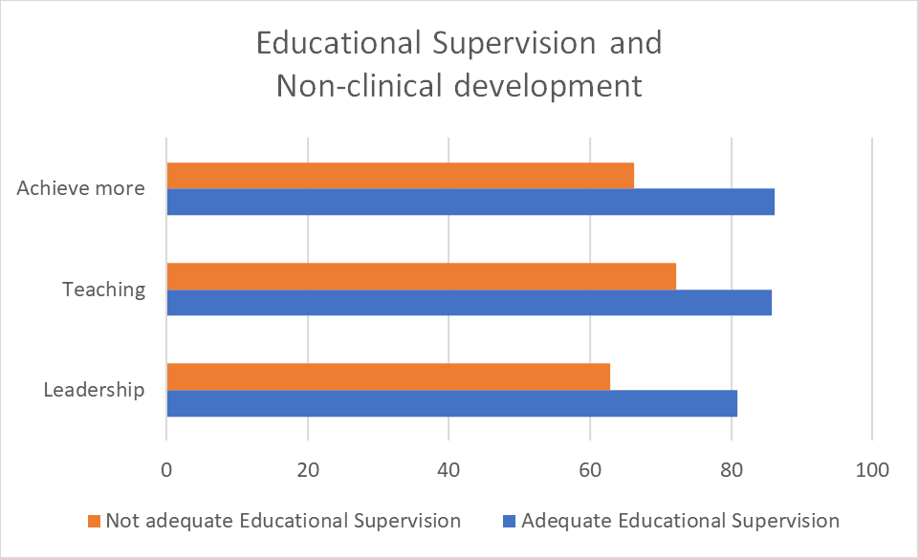

Clinical supervision
There is a correlation between good supervision in clinical practice and those respondents who had adequate Educational Supervision. There is significant evidence that adequate Educational Supervision is associated with good clinical supervision in gynaecology clinic (69.4% vs 58.5%), gynaecology out of hours (74.7% vs 64.9%) and labour ward (89.0% and 83.5%), as well as promoting independent practice (93.8% vs 81.9%).
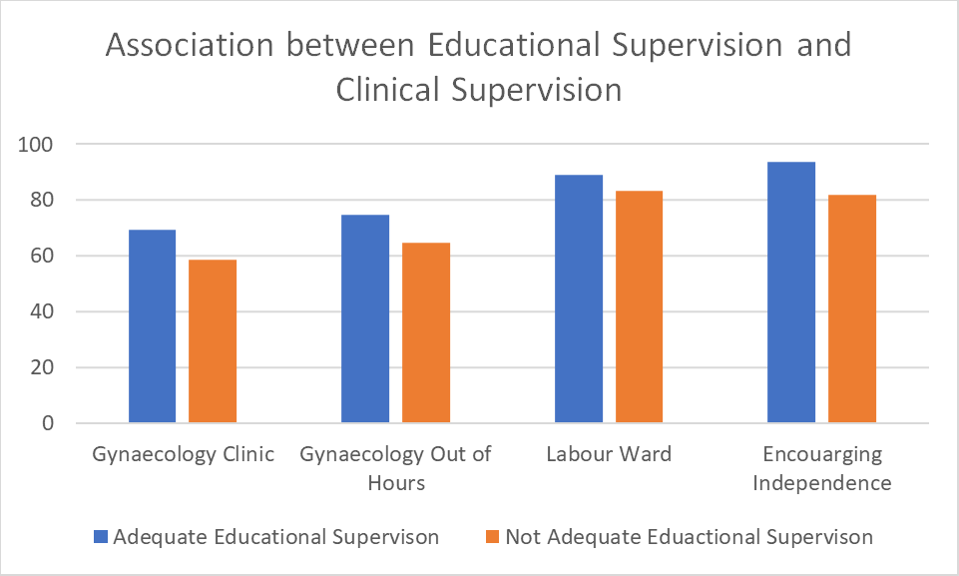
Where Educational Supervision is adequate, clinical feedback was more likely to be perceived as constructive (87.1% vs 72.8%) and workplace based assessments were more likely to be perceived as fair (87.8% vs 79.7%). Completion of NOTSS was also better supported (78.2% vs 54.8%).

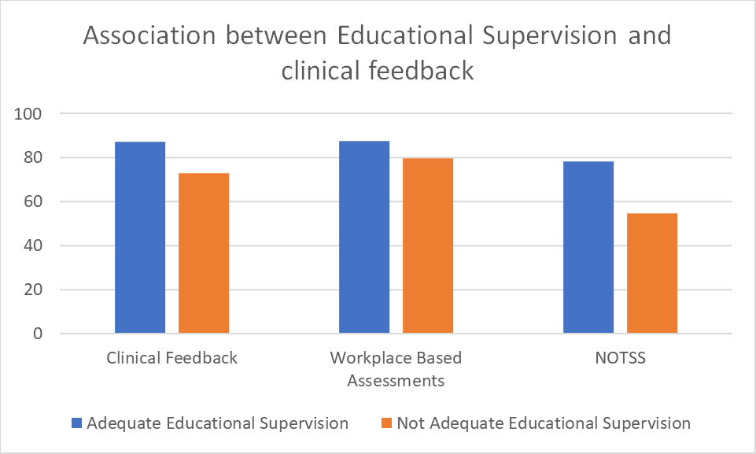

Discussion
The TEF results from 2023 show that Educational Supervision has an impact on all aspects of a trainee’s workplace experience, acquisition of clinical skills and career progression. Where Educational Supervision is timely, useful and carried out by a supervisor who is familiar with the curriculum and ePortfolio requirements, trainees are more likely to feel supported within the clinical setting, with better feedback from clinical supervisors and contemplate leaving the profession less often. Trainees are also more likely to feel able to develop non-clinical skills such as leadership and teaching. Workplaces which model good behaviours, such as embedding values of equality and diversity, are more likely to be associated with adequate Educational Supervision.

One of the starkest contrasts in the data shows that Educational Supervisor familiarity with the RCOG curriculum and function of the ePortfolio has a significant impact on how the trainee views the fairness and transparency of their annual evaluation (ARCP). Satisfaction with ARCP can be used as a surrogate marker of trainee’s satisfaction and engagement with the training programme provided in the deanery, which is vital for an individual’s career progression. This shows the importance of appropriate training of Educational Supervisors in delivery of their role.

To augment this data from trainees, we can compare it to the GMC National Trainers Survey in 2022, where 36% of clinicians within obstetrics and gynaecology responded. Of these respondents, only 53% felt they had enough dedicated time for training, 40.28% could use that time for training and 54.7% felt they could meet their trainee as often as required. However, 65.2% of trainers felt they were supported by their department in their role as a trainer and 56% felt supported by their trust and deanery. When compared to 64 other specialties, O+G came 31st when considering support for training, 15th for time to train and 32nd for resources to train.

These results show how important providing training for Educational Supervisors to deliver their vital role but this must run alongside time within the working week to provide supervision. Where this is possible, trainees are supported to develop in all aspects of their careers and are less likely to contemplate leaving the profession.

Looking at historical rating of educational supervision throughout the deaneries in the UK via the annual GMC trainee surveys, Northern Ireland, Scotland and KSS score consistently well from 2019-2023 with Green Flags for Educational Supervision.

Table from GMC Trainee Survey 2019-2023 for Education Supervision by Deanery
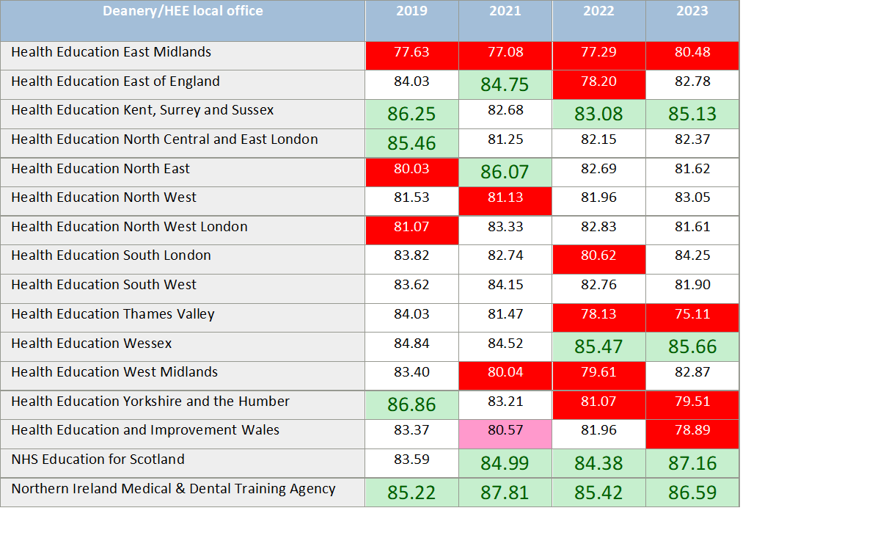
Summary of findings
- Adequate Educational Supervision is considered where timely and useful meetings by a clinician, who is familiar with the RCOG curricular and ePortfolio requirements, are carried out with a trainee.
- This has been done particularly well in Northern Ireland, KSS, Scotland and North West London
- Where Educational Supervision is adequate, all aspects of a trainee’s career are influenced for the better:
  - Improved clinical supervision and work placed behaviours
  - Development of teaching and leadership skills
  - Engagement with the training programme
  - Lower attrition rates
- Adequate Educational Supervision can be best provided where there is appropriate training of clinicians in supervision and time within consultant job plans is provided.

Recommendations
- Sharing of knowledge and experience from the top scoring deaneries
- Encourage awareness and utility of RCOG Educational Supervisor toolkit which is in development to support educational supervisors in their role:
- To promote knowledge of the RCOG curriculum and utility of ePortfolio
- To support trainers to provide pastoral support and development of good workplace based behaviours
- Consider development of an RCOG Educational Supervisor course to supplement the RCOG toolkit and upskill Educational Supervisors in the critical areas described.
- Use of the Educational Supervisor Report (ESR) feedback form in the ePortfolio at ARCP panels to improve the quality of ESRs.
- Recommend that educational supervisors are allocated 0.25 SPA time per trainee per week within their job-plans to allow them to provide adequate supervision for trainees.

References

Delva, D., Sargeant, J., Miller, S., Holland, J., Alexiadis Brown, P., Leblanc, C., Lightfoot, K. and Mann, K., 2013. Encouraging residents to seek feedback. Medical Teacher, 35(12), pp.e1625-e1631.
GMC (2022). National Training Surveys. Available at: https://www.gmc-uk.org/education/how-we-quality-assure/national-training-surveys [Accessed 12th January 2022]
GMC (2023). National Training Survey Results. Available at: national-training-survey-2023-initial-findings-report_pdf-101939815.pdf (gmc-uk.org) [Accessed 1st November 2023]
RCOG (2021). New Curriculum TEF Report. Available at: tef-2021-report-curriculum-2019-educational-supervision.pdf (rcog.org.uk) [Accessed 15th August 2023]
Gregory, S., Demartini, C. Satisfaction of doctors with their training: evidence from UK. BMC Health Serv Res 17, 851 (2017). https://doi.org/10.1186/s12913-017-2792-0

Find out more at
rcog.org.uk

