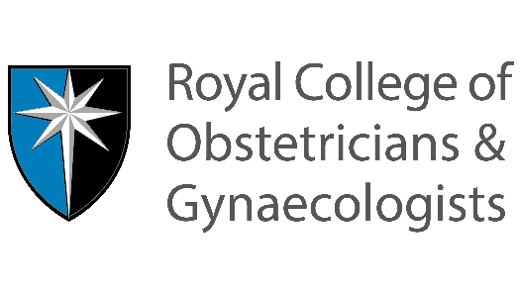

Team of the Shift emails

Email One:

Dear all,

As you know, through the EBCL&S programme, we’ve been improving clinical escalation with Teach or Treat, and AID. The last thing we’ll be introducing is “Team of the Shift”, tying everything together.

We know how hard things have been for everyone over the last 2 years – and how exhausted you all are. We also know that faced with such immense pressures, the little things that make our days better can sometimes slip, and it’s why we wanted to have a focus on looking after each other. It’s so important we foster a culture of kindness and civility, not only because in doing so we support each other, but also because we know that incivility can be crucially linked to patient safety.

So this campaign is all about optimal teamwork, and recognising that the little things we do – asking a colleague how they are, saying thank you, checking in with each other at the end of the shift - can go a long way towards making someone else’s day better. Our behaviours, positive or negative, can have a huge impact on others. By promoting a positive culture, we also enable psychological safety – making everyone feel valued, respecting and welcoming the input of every member of the team, and encouraging everyone to speak up without fear of blame or retribution. This in turn has a big impact on patient safety, enabling everyone to speak up when they have concerns.

It’s also so important to know your team for the day. Who are you going to escalate to? Who is going to escalate to you? Are you all ok? Does anyone need extra support? Or are there any learning or development needs to address?

We’ll be reminding you about this over the coming weeks, with cards and posters, amongst other things.

Email Two:

Dear all,

As part of our escalation interventions, promoting optimal teamwork, we are introducing the “Team of the Shift Huddle”.

This will involve a few tweaks to our existing (huddle / handover), to promote optimal teamwork, aid clinical escalation, and optimise patient safety.

Posters will be going up in clinical areas to act as prompts. It’s been broken it down here, to provide everyone with a full understanding.

- Set the expectations and the scene:
Reduce distractions – distractions can lead to error, with key information omitted
- Close door
- Ensure privacy and confidentiality
- Are there any immediate safety issues – delegate prior to Team of shift and Clinical handover.
Huddles and handovers can be the most dangerous time of the day as all the key team members are distracted. It’s important to ensure time critical issues are dealt with prior to starting a huddle. However, it’s also important as many of the incoming team are present as possible, in order to ensure everyone has the same shared mental model and key information isn’t lost. Consider delegation – an example could be a consultant covering a different area, eg the caesarean section list.

- Welcome incoming team
- Ask how they are? (anyone hungry, angry, late, tired or distracted). (We know that any or all of these things can affect our working memories and our situational awareness)
- Let people know who to talk to if they want to talk to someone privately (eg if they need to debrief from a previous shift, or have personal concerns that may affect their performance at work).

- Introduce: 5-10mins for Team of the Shift then clinical handover.
(Huddles and handovers are a time when a large number of the team are away from clinical activity. It’s therefore imperative that they start promptly, and take as short a time as possible whilst being as thorough as necessary, and giving everyone the opportunity to speak up. There should be no criticism or undermining, either of the outgoing team, or the choices of women / birthing people have made).

- Team introductions and identification

- Name and role
- Shift duration e.g. early, late, long day etc
- Any support/skill development needs
(This is a crucial part of successful clinical escalation – everyone clearly knows who they are working with that day, and in what capacity. Introducing everyone by their first name flattens the hierarchy and encourages all staff to speak up and escalate. Addressing support and skill / development needs makes all members of the team feel valued).

- Identify emergency team, their roles and any potential emergencies anticipated. (This ensures everyone has the same shared mental model – and helps when emergency buzzers are pulled. A key part of maintaining situational awareness is preparation and planning).

- Identify who to escalate to and any escalation buddies. (Knowing who to escalate to and when is a crucial part of clinical escalation).

- Clinical handover

- Thank outgoing team

- What went well?
- Is everyone ok?
(It’s so important to check in with our colleagues, particularly at the end of a long shift. We need to remember what an amazing job we all do, every single day, saving many lives. As a team, learning from excellence and celebrating successes fosters a culture of joy at work)

